**Aim:** Exploring the basic functionality of excel using pivot table.

**IDE:** Microsoft Excel 2013

**Questions:**

1. **Average "total cost" and count of the product 1 under small order category**

* Make Pivot Table for given Dataset.
* Insert Product_# with Filter to Product-1 and Category_# with Small Category In Row Field.
* Insert Total Cost in the Value Field and Change the value in Average Mode and Insert Order_# and Change the Setting into Count Mode.
* **Answer :-** Count – 11

Average Total Cost = $50.73

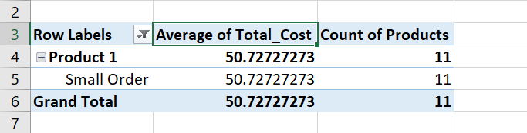

1. **Average "total cost" and count of the product 1 under normal order category**

* Make Pivot Table for given Dataset.
* Insert Product_# with Filter to Product-1 and Category_# with Normal Category In Row Field.
* Insert Total Cost in the Value Field and Change the value in Average Mode and Insert Order_# and Change the Setting into Count Mode.
* **Answer :-** Count – 14

Average Total Cost = $151.71

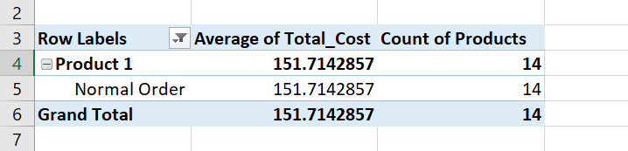

1. **Average "total cost" and count of the product 1 under large order category**

* Make Pivot Table for given Dataset.
* Insert Product_# with Filter to Product-1 and Category_# with Large Category In Row Field.
* Insert Total Cost in the Value Field and Change the value in Average Mode and Insert Order_# and Change the Setting into Count Mode.
* **Answer :-** Count – 32

Average Total Cost = $402.75

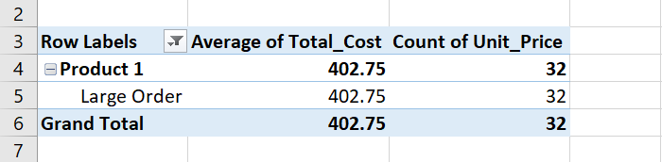

1. **Which month is having the highest count of orders placed?**

* Insert New Colum named month.
* Insert formula **=MONTH(G2)** where G2 is the cell where date of that order is written. Drop down the formula till last row.
* Now Insert A Pivot Table for Given Dataset.
* Insert a Month in a Row Field and Insert Order_# in Value field Change Setting into Count Mode and Sort the Column in Largest to Smallest. In First Row you will get your answer.
* **Answer :-** November – 11

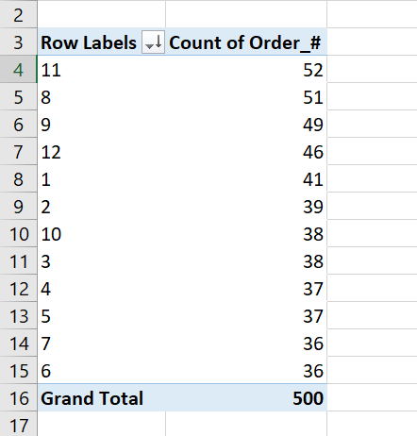

1. **Which year has the highest "average total cost"?**

* Insert New Colum named month.
* Insert formula **=YEAR(G2)** where G2 is the cell where date of that order is written. Drop down the formula till last row.
* Now Insert A Pivot Table for Given Dataset.
* Insert a Year in a Row Field and Insert Total_Cost in Value field Change Setting into Average Mode and Sort the Column in Largest to Smallest. In First Row you will get your answer.
* **Answer :-** Year 2011. Average Total Cost :- $152.7403

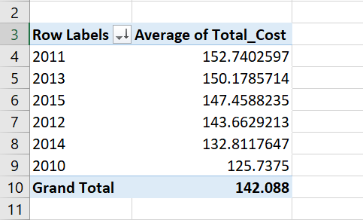

1. **What is the ratio of the number of orders placed by male and female ?**

* Insert a Formula in a new cell =**(COUNTIF($D$2:$D$501,"Male")/COUNTIF($D$2:$D$501,"Female"))**
* **Answer :-** Male = 219 , Female = 281 , Ratio = 0.77935943

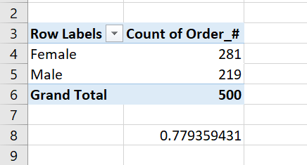

1. **What is the ratio of the total cost of the orders placed by male and female ?**

* Insert a Formula in a new cell **=(SUMIF(D2:D501,"Male",M2:M501) / SUMIF(D2:D501,"Female",M2:M501))**
* **Answer :-** Male = $33603 , Female = $37441 , Ratio = 0.89749205

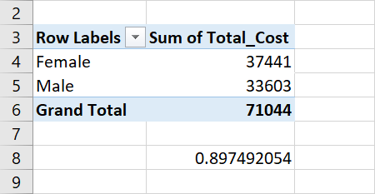

1. **How many orders are placed under each order category for the country "INDIA" ?**

* Select Filter Option. Select “INDIA” from Country Column and Select one by one category from Order_Category and count the number of orders after applying filter.
* **Answer :-** Small – 5 , Normal – 5 ,Large – 11

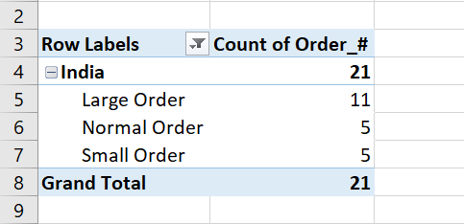

1. **What is the total cost of order placed by the customer "Willis Brinks"**

* Select Filter Option. Filter the Name Column and Select the Name as "Willis Brinks" and Select the column total cost after applying filter. And You will get the Total Sum in the bottom right corner.
* **Answer :-** $1214.00

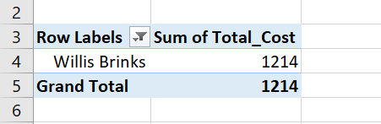

1. **Name the customer who has placed the order having the highest amount.**

* Insert A Formula in a new cell **=INDEX(C2:C501, MATCH(MAX(M2:M501), M2:M501, 0))**
* **Answer :-** Britni Baisden

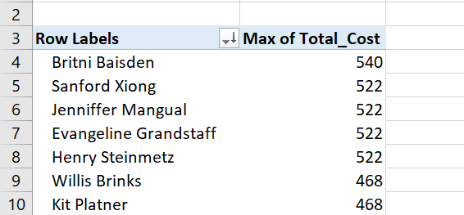

**Output:**

**Observation and Learnings:**

By Attempting this assignment we came to know the Various Functionalities of Microsoft Excel.